Ex 7. ESP32 multi-tasks with FreeRTOS

Write programs for ESP32 using multi-tasking with FreeRTOS. The program has 3 tasks:
Task 1: blink LED
Task 2: Read data from sensors (DHT, PIR motion sensors as in exercise 4)
Task 3: Send the sensors data to a server (postman server as in exercise 5)
Using wokwi https://wokwi.com/
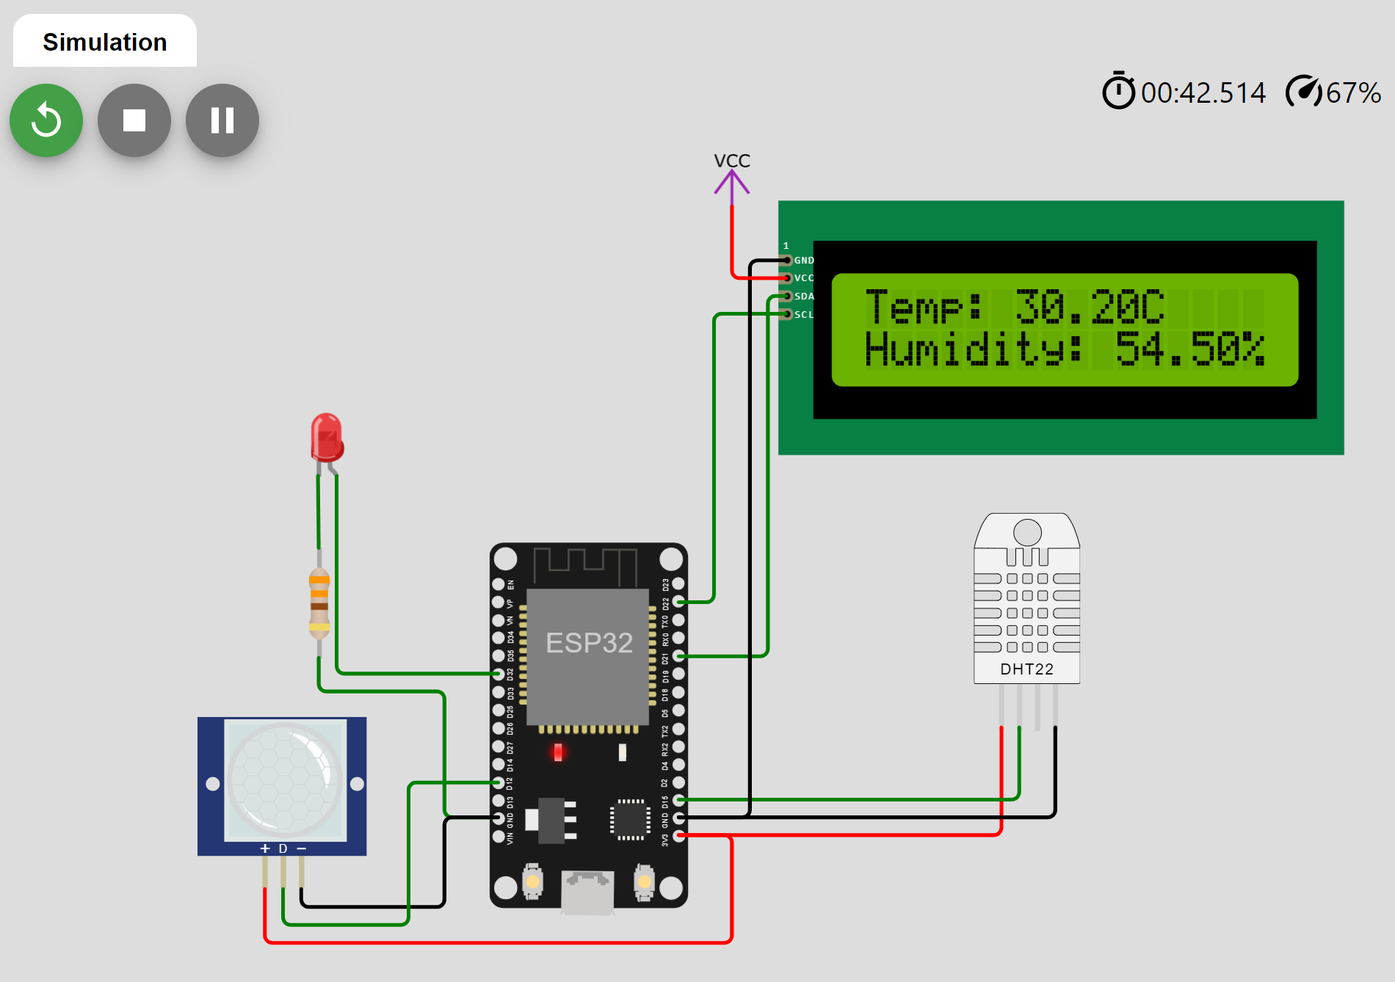

Using the server api:
https://postman-echo.com/get
https://postman-echo.com/post

Sample code:
#include "DHT.h"
#include <HTTPClient.h>
#include <WiFi.h>
#include <string.h>
const char* ssid = "HUNG-DELLPC";
const char* password = "hung1234" ;

#define DHT_PIN 15
#define DHT_TYPE DHT22

//Task 1: blink LED
void BlinkLED( void *pvParameters );
//Task 2: Read data from sensors
void ReadSensors( void *pvParameters );
//Task 3: Send data to server
void SendData(void *pvParameters);

const int led1 = 2; // Pin of the LED
DHT dht = DHT(DHT_PIN, DHT_TYPE);

void setup(){
pinMode(led1, OUTPUT);
dht.begin();
Serial.begin(9600);
Serial.println("Multi-tasking with FreeRTOS ...");

//setup wifi
WiFi.begin(ssid,password);
Serial.println("conecting");
while(WiFi.status() != WL_CONNECTED)
{
delay(500);
Serial.print(".");
}
Serial.println("");
Serial.print("Connected to WiFi network with IP Address: ");
Serial.println(WiFi.localIP());

//Create the task 1 to run BlinkLED
xTaskCreate(
BlinkLED, // Function that should be called
"Blink LED", // Name of the task (for debugging)
1024, // Stack size (bytes)
NULL, // Parameter to pass
1, // Task priority
NULL // Task handle
);
//TODO: create task 2, task 3
}

//The function for Task 1
void BlinkLED( void *pvParameters ){
for(;;){ // infinite loop
// Turn the LED on
digitalWrite(led1, HIGH);
// Pause the task for 500ms
vTaskDelay(500 / portTICK_PERIOD_MS);
// Turn the LED off
digitalWrite(led1, LOW);
// Pause the task again for 500ms
vTaskDelay(500 / portTICK_PERIOD_MS);
Serial.println("LED is blinking ...");
}
}

//The function for Task 2
void ReadSensors( void *pvParameters ){
//TODO
}

void SendingData(void* pvParameters){
//TODO
}

void loop() {
// put your main code here, to run repeatedly:

}

Submission:
Write a report with:
- The code of programs with suitable comments
- Screen photos when running programs
- Link of simulations with wokwi

